

YOUR DREAM YOUR PASSION
CODE ALPHA REMOTE INTERNSHIP 2026
- STUDENT NAME: ALEEM SHOUKAT
- STUDENT ID: CA/DF1/113502
- INETRNSHIP DOMAIN: DATA ANALYTICS
- DATE: 09/JUNE/2026
- TASK # 01
(Exploratory Data Analysis (EDA))

Netflix Exploratory Data Analysis (EDA)
1. Introduction
Exploratory Data Analysis (EDA) is an important step in the data analysis process that helps understand the structure, quality, and characteristics of a dataset before performing advanced analysis. This project analyzes a Netflix dataset to identify content trends, content types, ratings, genres, countries of production, and other important insights.
The objective of this analysis is to explore the dataset, clean the data, identify patterns, and visualize findings that can support data-driven decision-making.

2. Dataset Overview
The dataset contains information about Netflix Movies and TV Shows.
Dataset Information
- Total Rows: 200
- Total Columns: 12
Features Included
- show_id
- type
- title
- director
- cast
- country
- date_added
- release_year
- rating
- duration
- listed_in
- description

3. Data Cleaning
Data cleaning was performed to improve the quality and reliability of the dataset.
Missing Values Before Cleaning
Column | Missing Values
country | 64
director | 63
cast | 20
Data Cleaning Steps
- Missing values in country were handled.
- Missing values in director were replaced with "Unknown".
- Missing values in cast were handled appropriately.
- Dataset consistency was verified.
- Duplicate records were checked.
Duplicate Records
Number of duplicate records found:
0
Missing Values After Cleaning
All missing values were successfully handled.
Column | Missing Values
All Columns | 0
The dataset became complete and ready for analysis.

4. Statistical Analysis
Several statistical techniques were applied to understand the dataset and identify meaningful insights.
Content Type Distribution
Content Type | Count | Percentage
Movies | 127 | 63.5%
TV Shows | 73 | 36.5%
Observation
Movies represent the majority of content available in the dataset, indicating that Netflix offers a larger collection of movies compared to television shows.

Content Ratings Analysis
The most common content ratings are:
Rating | Count
TV-MA | 50
TV-14 | 34
PG-13 | 28
R | 23
TV-PG | 22
Observation
TV-MA is the most common rating category, suggesting that a significant portion of Netflix content is designed for mature audiences.

Release Year Analysis
Most Frequent Release Years
Release Year | Count
2021 | 78
2020 | 13
2017 | 8
2018 | 7
2003 | 7
Statistical Summary
- Earliest Release Year: 1961
- Latest Release Year: 2021
- Median Release Year: 2018
Observation
Most content in the dataset was released in recent years, particularly in 2021, indicating continuous growth and expansion of Netflix's content library.

Director Analysis
Top Directors:
Director | Count
Toshiya Shinohara | 4
Masahiko Murata | 3
Antoine Fuqua | 2
Hajime Kamegaki | 2
Kemi Adetiba | 2
Observation
Toshiya Shinohara appears most frequently among directors in the dataset.

Genre Analysis
Top Genres:
Genre | Count
Action & Adventure, Anime Features, International Movies | 12
Kids' TV | 8
Children & Family Movies | 6
Dramas, International Movies, Thrillers | 6
Kids' TV, TV Comedies | 6
Observation
Action, Adventure, Anime, and International content are among the most frequently appearing genres in the dataset.

Country Analysis
Top Country:
United States (50 Titles)
Observation
The United States contributes the highest number of titles, making it the leading content-producing country in the dataset.

5. Data Visualization
Several visualizations were created to better understand patterns and trends within the dataset.
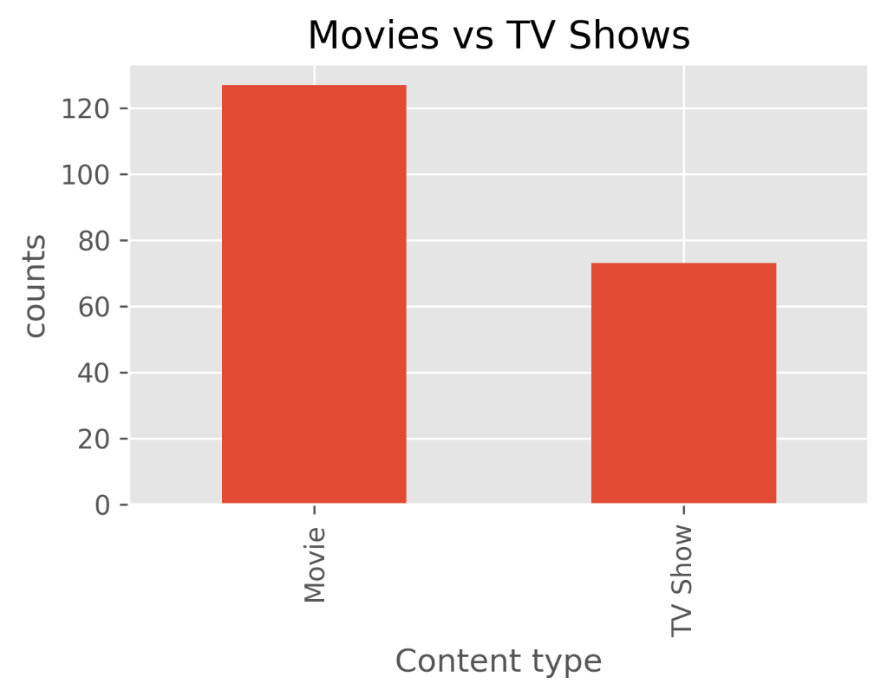
Visualization 1: Movies vs TV Shows

Purpose: To compare the distribution of Movies and TV Shows available on Netflix.

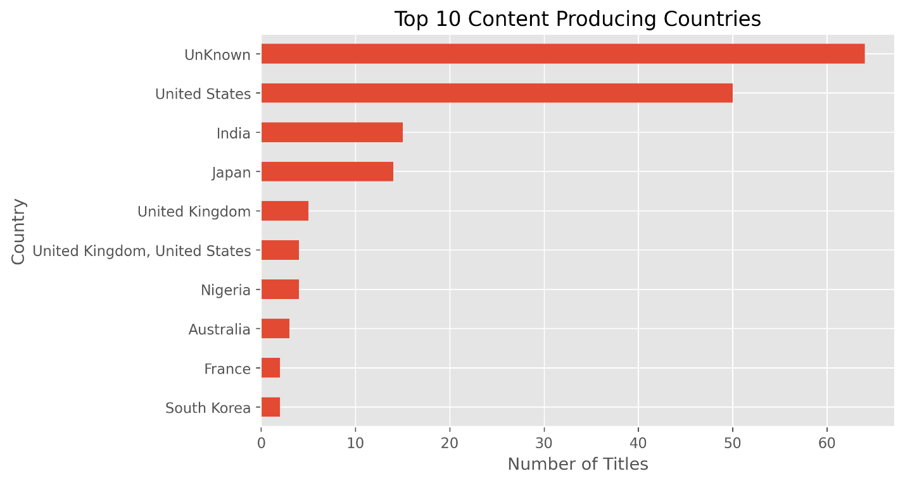
Visualization 2: Top Content Producing Countries

Purpose:
To identify the countries contributing the highest amount of content.

Visualization 3: Rating Distribution
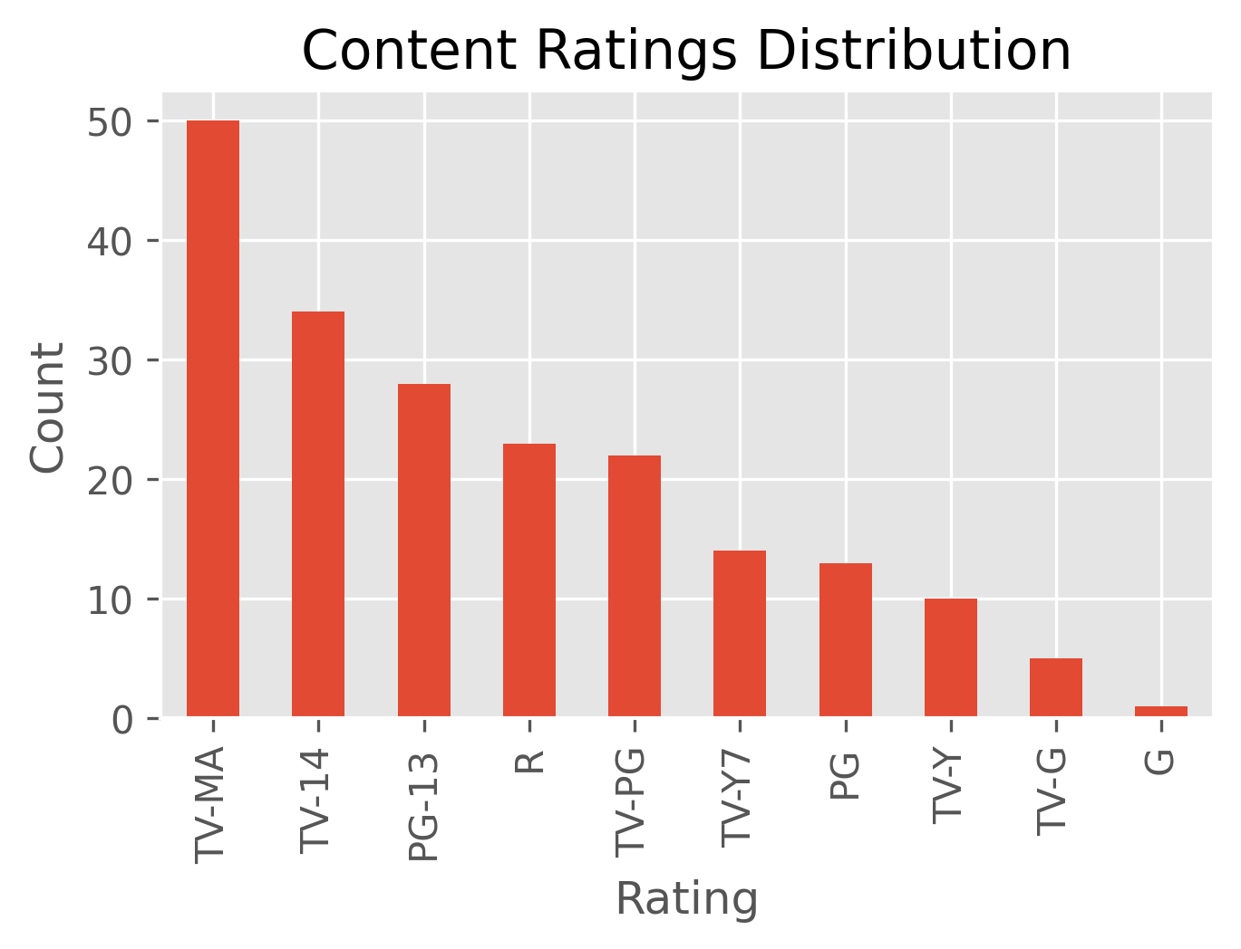

Purpose: To understand audience targeting through content ratings.

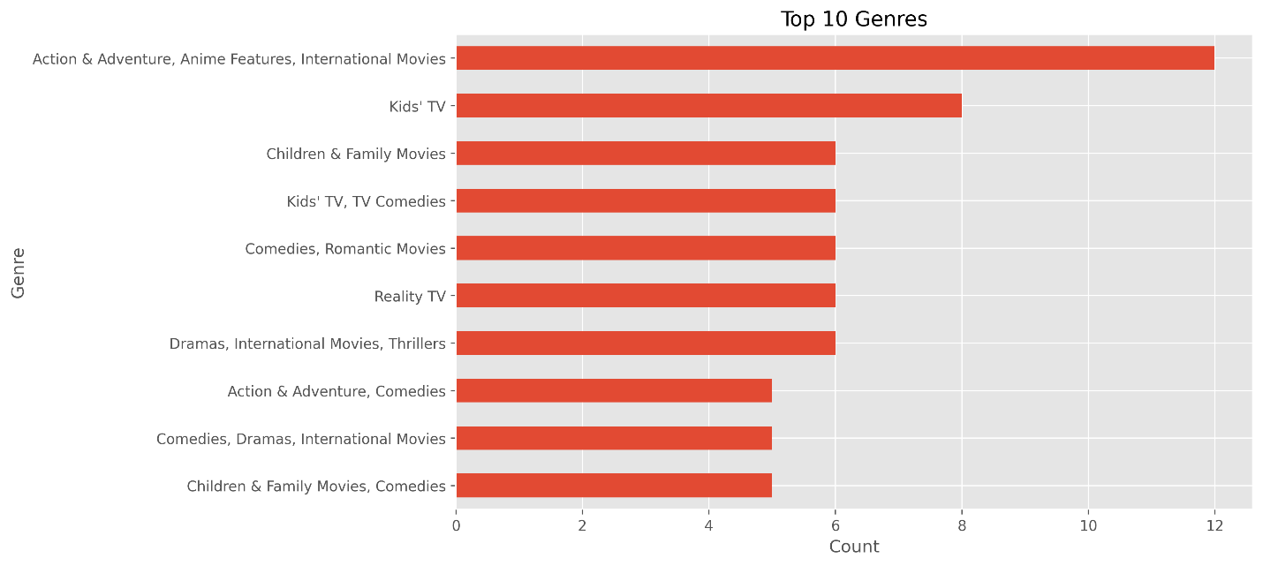
Visualization 4: Top Genres

Purpose:
To identify the most common genres available on Netflix.
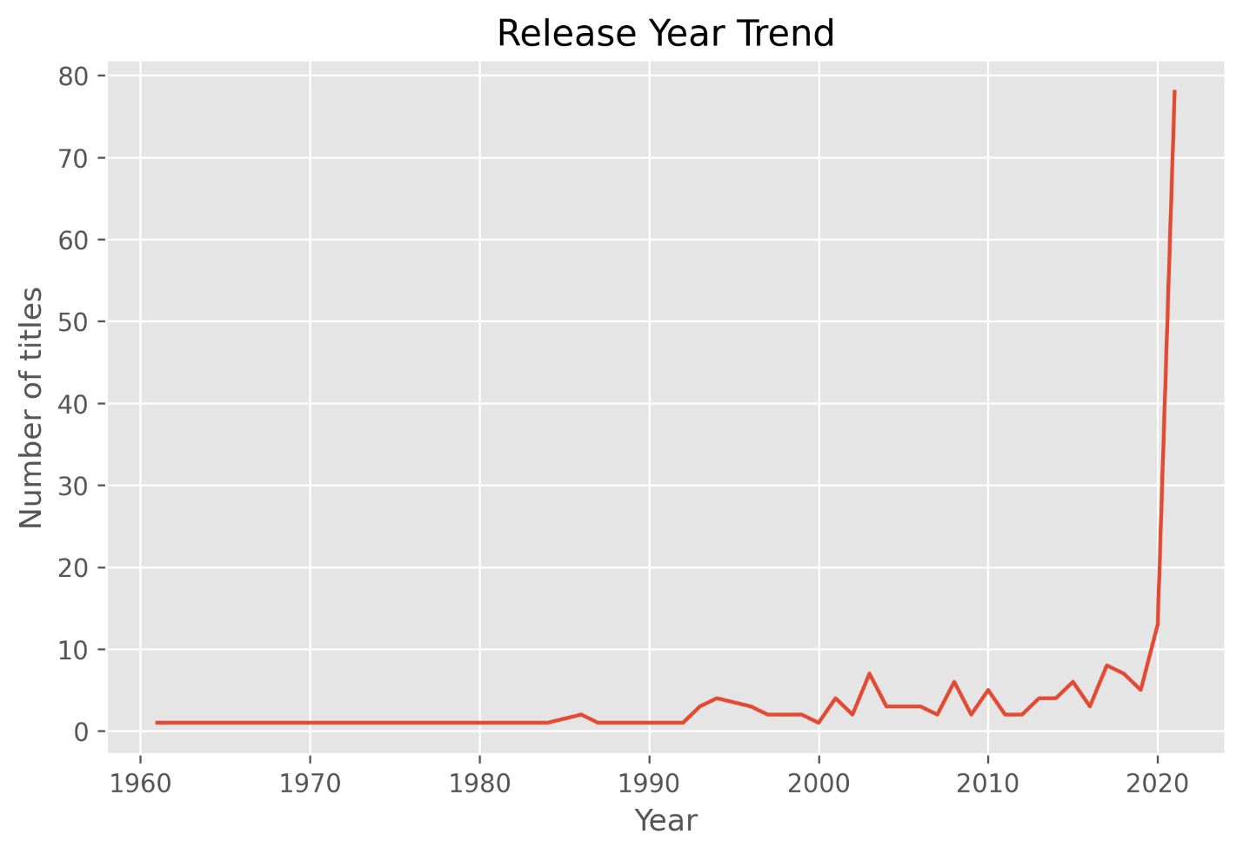
Visualization 5: Release Year Trend

Purpose:
To analyze content release trends over time.

6. Key Findings
- Movies dominate the dataset, accounting for 63.5% of all content.
- TV Shows account for 36.5% of the dataset.
- The United States is the leading content-producing country with 50 titles.
- TV-MA is the most common content rating, indicating a strong focus on mature audiences.
- Action & Adventure, Anime Features, and International Movies are among the most popular genres.
- Most content in the dataset was released recently, with 2021 showing the highest number of releases.
- Toshiya Shinohara is the most frequently appearing director in the dataset.

7. Recommendations
Based on the analysis, the following recommendations can be considered:
- Continue investing in movie content, as movies represent the largest share of available content.
- Expand production partnerships in countries outside the United States to increase content diversity.
- Increase genre diversity to attract broader audience segments.
- Analyze audience preferences for TV-MA content to support future content planning.
- Continue monitoring content trends to align future releases with audience interests.

8. Conclusion
This Exploratory Data Analysis successfully examined a Netflix dataset containing 200 records and 12 features. Through data cleaning, statistical analysis, and visualization, several meaningful insights were identified regarding content types, ratings, genres, directors, release years, and countries of production.
The findings indicate that Netflix's content library is primarily movie-oriented, heavily influenced by productions from the United States, and largely targeted toward mature audiences. The analysis demonstrates how EDA can be used to transform raw data into actionable insights that support informed decision-making.

-----------------------------------

